Alexander King
CSET 3200
Midterm report
9.30.19

The history of computer programming.
In the 1800s punch cards were used in textile manufacturing. This allowed for more complex automated designed. In 1842 mathematician Charles Baggage was aware the punch cards being used by the textile industry and wanted to make a calculator with the punch cards. He created these with Ada Lovelace who is often cited as the first “programmer”. Base 10 was used for this machine (hole / no hole). This also utilizes and builds on Boolean logic. Everything we put into a computer is ultimately translated into binary so this still exists to an extent today.
In 1906 Herman Hollerith created a tabulator that didn’t need to be reset each time in ran code. His machine was used to count people for the census and reduced what used to take roughly eight years down to two. He would found companies that would later become IBM. (Ibm.com, 2019)
During the late 30s through mid 40s World War Two was bring fought which led to some really cool hardware programming for encryption and decryption. These would would be a foundation to later software iterations we’re more familiar with like RSA. IBM developed Automatic Sequence Controlled Calculator (ASCC) Harvard Mark 1 (Figure 1). It was used during for war effort to perform complex calculations for the US Navy as well as The Manhattan Project. (Harvard.edu, 2019)
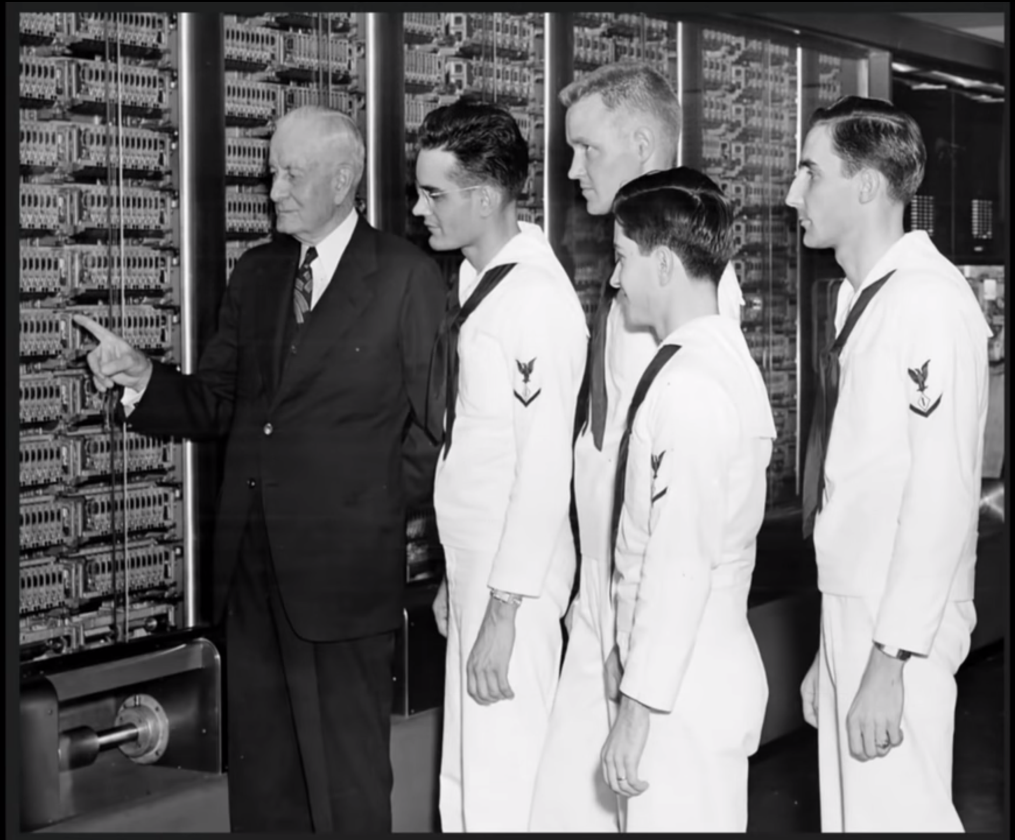Figure 1: IBM president and US Navy Personnel ASCC Harvard Mark 1 < https://www.cio.co.uk/it-leadership/ibm-history-pictures-3429430/ >

In 1946 Project PX also known as Electronic Numerical Integrator and Computer (ENIAC) was publicly revealed. Started in 1943 by the US Army at The University of Pennsylvania Moore School of Electrical Engineering for the war effort. It made complex calculations for the US Army. It was a massive series of vacuum tubes that were manually programming by setting switches and connecting wires. Setting a single program could take weeks. ENIAC also utilized an IBM punch card reader for inputs and a card punch machine for output. It performed complex calculations for the military that used to take hours could not take minutes. It also provided weather predictions. (Computer History Archives Project, 2019)

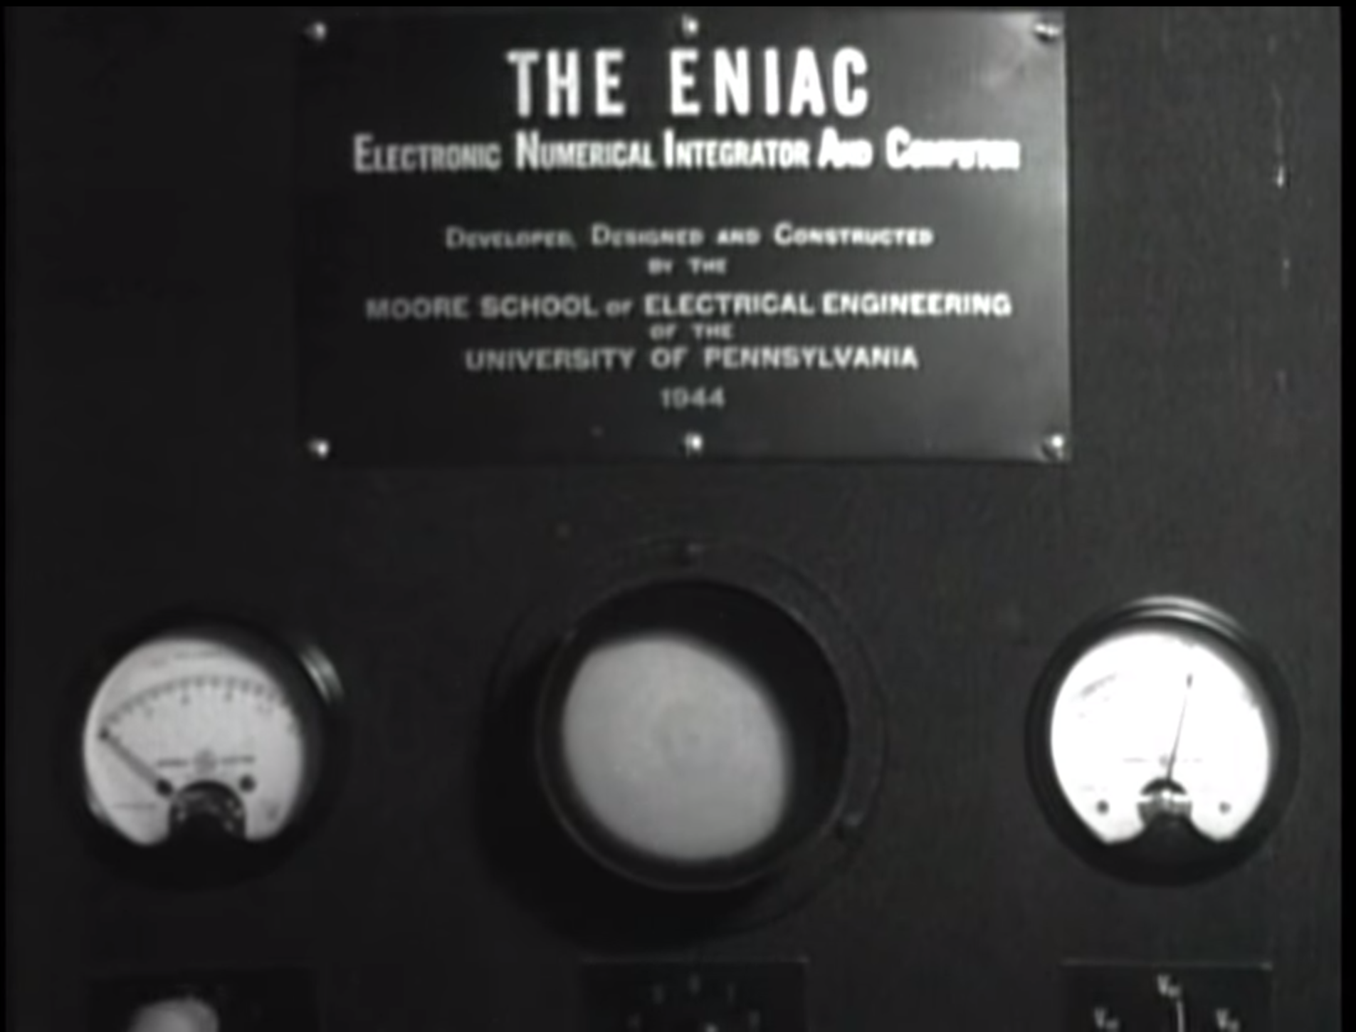Figure 2: ENIAC
In 1956 the UNIVAC correctly predicted the 1956 US presidential election and did it more accurately than pundits. This made the unit famous in popular culture and started making appearances in movies. It performed calculations on small amounts of polling data. This was also the first computer to use magnetic storage instead of punch cards. (Cs.calvin.edu, 2019)
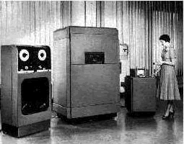Figure 3: UNIVAC television debut correctly predicting the 1956 US presidental election < https://cs.calvin.edu/activities/books/rit/chapter2/images/univac.gif >

In 1954 IBM created FORTRAN (FORmula TRANslation). It was originally developed for scientific and engineering problem solving. It is the foundation to higher level programming languages such as C++ and HTML. This also still sees some use today. (Ibm.com, 2019)

In 1954 Common Business-Oriented Language (COBOL) became the first user-friendly business software program. Grace Hopper previously worked on The Harvard Mark 1 and Univac. She led the team that created COBOL.

During the 1970s we had the personal computer revolution where for the first time personal computers were being manufactured for personal use and were somewhat obtainable in large scale. In the 1980s we started getting our first GUIs. The 1990s really brought computers into the home with the advent of the consumer internet. ISPs like the one my parents owned UsaFirst.net began offering home internet connections and it again revolutionized how people used their computers. After the release of Windows 95 computer prices dropped drastically and were popping up everywhere. Small businesses started acquiring them around this time too. In 2007 Apple released the first iPhone. This would be another revolution that changed how most people used the internet and the programs we create. The history of the programs we write and how we write them is still being written. HTML4.x→5 for example. Java has had a rich history of vulnerabilities for end users which has changed and affected how we code. Many programs and services are starting to finally support data encryption which is a direct result of current event mass surveillance.
The hardware architecture used by modern computers (Von Neumann Architecture)
The Von-Neumann architecture: A user gives an input that is run through a program and processed by the CPU/RAM and then provides an output. The von-neumann bottle neck is the speed of the bus is slower than the memory or CPU speed.
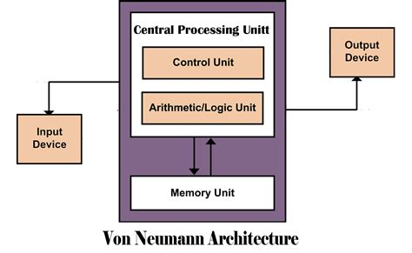Figure 4: Georgetown University - < https://blogs.commons.georgetown.edu/cctp-820-fall2016/category/week-7/ >

Structured programming – how it works and why we use it
Structured programming is modular programming. Having sub-programs that can be more easily changed and or reused. Structured programming will use commands like if while and for instead of commands like do. We do this because it allows the code to be more easily used elsewhere or discarded. It also helps us work in teams more easily because we can all work on our own sections independently. This is advantageous in my opinion because coders wont have interference or unknown mystery edits happening in their assigned portion of the work.
Compiler -vs interpreter vs hybrid
Compiled programs are translated into machine language. This includes JIT systems. They’re used in large commercial applications. Pure Interpreters are interpreted by another program known as an interpreter. Hybrid implementation is a compromise between compilers and pure interpreters. Small and medium systems where efficiency is not the first concern.

Explain in detail the history and overview of the client-server architecture
Client Server connections have been used for DNS looking up internet addresses to be able to more easily navigate the internet. Telnet is an outdated now insecure way to make connections. File Transfer Protocol and provide files as a service to clients.
a) Client-server: Clients connect to servers for use of services.
b) 3 tier systyems: Three processes collaborate in chains. The end user handles presentation (GUI) as well as user inputs, the application tier makes all of the application decisions, and the data tier stores data utilized by the application tier. This can add security as well as improved performance under heavy workloads.
c) N-Tier System n-tier can be any n-number of tiers.
Explain difference between a client, server and a service.
Client – end user. The individual connecting to a server. - My home desktop computer

Server – provides services to the end user. The client connects to the server. *A server is one or more multi-user processors with shared memory providing computing, connectivity and the database services and the interfaces relevant to the business need.* - My home computer when it is providing services to other devices. EX: My gf wants to play a game so she connects to my shared drive that lives inside of my desktop and launches the game.

Service – a task accomplished and provided by the server to a client. My installation of a game in the example above when utilized by another device is a service.

Shared resource – If 2 or more clients are connecting to a server for the same service it is a shared resource. The server has X amount of computing power and it is shared. No one user should be able to demand it all.

A client is an end user. The end user connects to a server which provides services. For example if I want to know what time it is in another time zone I can connect to a server and utilize a service that asks me what timezone I am interested in knowing the time of. I will tell the server which time zone I find interesting and it will output the current local time for that timezone. A good example of a shared resource would be an online gaming server that players connect to.

Examples and definitions of different types of servers
File servers deliver files. My home desktop acts as a file server for shared HDDs that my entire LAN has read-access to.

Database Servers allow us to store and query large amounts of data. This could be log-in credentials. SQL is commonly used.

Transaction Server: The client can invoke remote procedure or services that reside onthe server with an SQL database engine using the transaction server. I think this is basically the reason why I have to pay for something like www.sc2replaystats.com. I cannot inspect their elements to just get what I want it calls the fun bits from another server.

Groupware Servers: I think these are what I utilize when I connect with an online tutor through their new software.

Comparison between Client-Server, Peer to peer, and single process (stand alone) architectures.
Client-servers connections can be advantageous because you can assert more access control. It is easier to keep out pirates and anyone you don’t want utilizing your services. Disadvantages are that both the client and server must maintain a steady internet connection . This also creates additional security concerns vs if it were offline. Another major advantage to this system is that the server can have far more processing power and RAM than is feasible for their consumers to have. This gives rise to services like online hash crack to recover forgotten passwords that would realistically be un-crackable for their customers due to execution time.
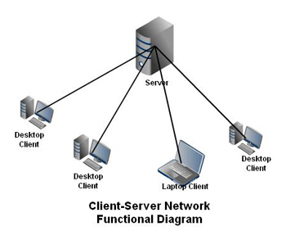Figure 5: Client Server Diagram <https://andrewmagdurulan.files.wordpress.com/2012/11/4774clientservernetworkdiagram.jpg?w=350&h=293>
Peer-to-peer is a wonderful system where ideally many people with the entire file (seeds) share with fewer people who want or need the file (leaches). Microsoft utilizes this to push their windows updates and it saves on bandwidth by pushing it onto consumers who do not opt-out. The main downfall of this is that unless one utilizes a proxy and or VPN their IP address will probably be visible to users around the world. This could cause additional security concerns. I think content superpower governments would rather not be publicly available remaining consistently publicly available is a testament to its robustness. Peer-to-peers performance can vary. It is heavily dependent on seeds. If you have a good enough connection between the peers it can offer the same advantages of client-server. Non-ideal conditions will provide sub-par execution times.
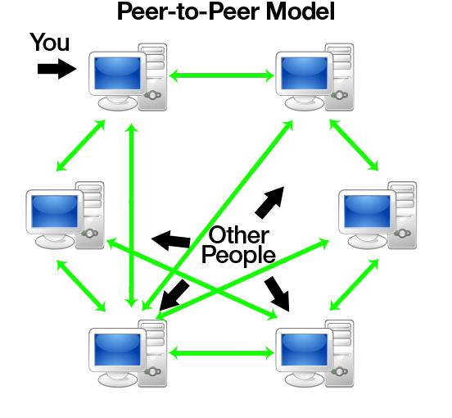Figure 6: Peer-to-peer diagram < https://www.codeproject.com/KB/WCF/614028/pto1.png >

Single process programs are able to be run offline. This is a major advantage compared to client-server and p2p. The major disadvantage is that it becomes an impossible task to maintain DRM. If you’re program is high quality and demanded people will steal it. The execution time will depend entirely on the individual device the program is being run on. All processing power and RAM demands will come from the device. This is usually disadvantageous if it were possible to relocate the workloads to a shared server with superior capabilities compared to the average users device.

Differences in delivery system thick vs thin client programming
Thin == the email program we made for Homework 5. Will NOT work offline.
Thick == Photoshop. It is functional offline but has some features that utilize online.
Something browser based is more easily controlled if the ability to solve the problem is never given to the user in a way they can use offline. This can be a positive for the intellectual property owner because they can direct the traffic where they want. They can require log-in accounts or subscriptions more easily etc. The downside to this approach is both the client and the server must maintain an internet connection and there is a wider attack surface for nefarious actors to create problems.

The advantages of a desktop exe is that it can be run offline and thus has fewer attack vectors. The disadvantages are an ability to implement DRM. Your program will be cracked and freely distributed if it is of high enough quality and demand. Attempting to implement working DRM will annoy paying customers who run into problems and you will fail anyways.

Bibliograpyh

Harvard.edu. (2019). About the Mark I. [online] Available at: https://sites.harvard.edu/~chsi/markone/about.html [Accessed 8 Oct. 2019].

Computer History Archives Project (2019). 1946 ENIAC Computer History Remastered FULL VERSION First Large Digital Elec.Computer Educational. [online] YouTube. Available at: https://www.youtube.com/watch?v=bGk9W65vXNA [Accessed 8 Oct. 2019].

Ibm.com. (2019). IBM Archives: Herman Hollerith. [online] Available at: https://www.ibm.com/ibm/history/exhibits/builders/builders_hollerith.html [Accessed 8 Oct. 2019].

Ibm.com. (2019). IBM100 - FORTRAN. [online] Available at: https://www.ibm.com/ibm/history/ibm100/us/en/icons/fortran/ [Accessed 8 Oct. 2019].

Ibm.com. (2019). IBM100 - The Punched Card Tabulator. [online] Available at: https://www.ibm.com/ibm/history/ibm100/us/en/icons/tabulator/ [Accessed 8 Oct. 2019].

Cs.calvin.edu. (2019). UNIVAC. [online] Available at: https://cs.calvin.edu/activities/books/rit/chapter2/history/univac.htm [Accessed 8 Oct. 2019].

